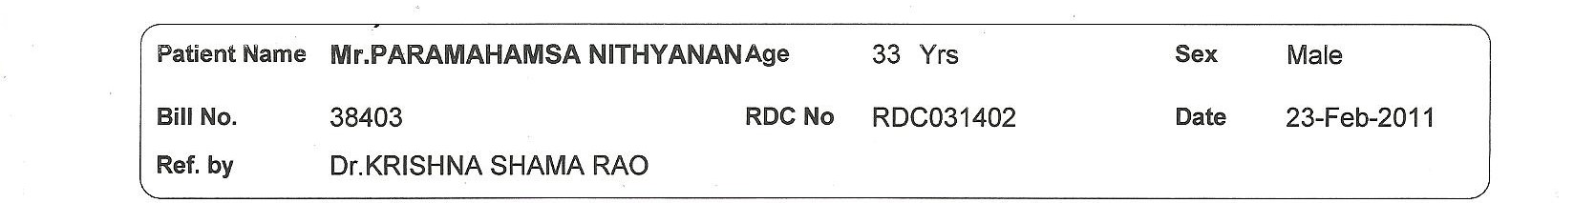

**Breast Cancer Report**

|  |  |  |  |
| --- | --- | --- | --- |
| **radius_mean** |  | **radius_se** |  |
| **texture_mean** |  |  |  |
| **symmetry_mean** |  |  |  |
| **perimeter_mean** |  |  |  |
| **smoothness_mean** |  |  |  |
| **concavity_mean** |  |  |  |
| **concave points_mean** |  |  |  |
| **fractal_dimension_mean** |  |  |  |
| **radius_se** |  |  |  |